**CAMOSUN COLLEGE**

**ELECTRONICS DEPTARTMENT**

**ECET 165 - LAB 2**

**I HAVE SEEN THE LIGHT!**

In this lab we are going to program our first piece of code into a PIC 18F57Q43. This uC is a flash based processor that is capable of doing many things.

Create a E165L02LightXX project where XX is your intials using the MPLAB Project Wizard. Save your assembly file as E165L02LightXX.s where XX is your intials. Note, it is important that you comment your source code.

## Objectives

Part 1

The objective of this lab is to turn on the onboard LED when the onboard switch is pushed. When the switch is inactive the led should turn off. You should step through the code to see how each part of the code works.

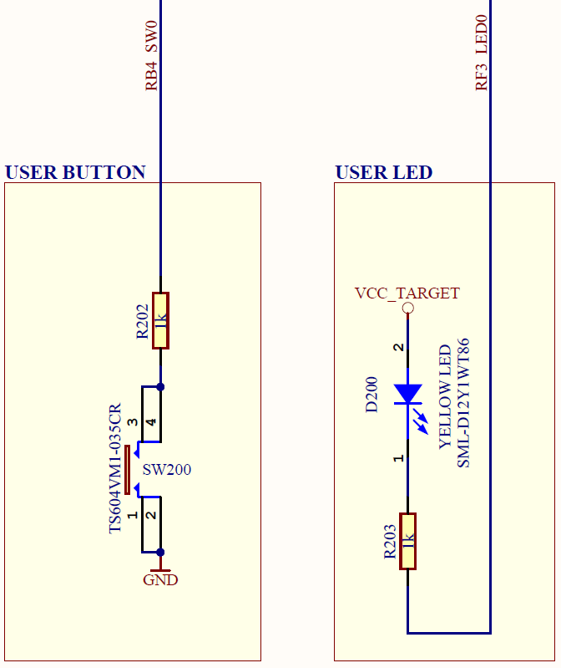

**Report**

Your report should include a complete documented code listing.

**Optional Challenge:**

Modify your code to now debounce the switch. All switches have what is known as switch bounce. In order to use switches correctly with digital logic, this bounce must be removed. It is generally considered that switch bounce only exists for about 10ms to 30ms although you will come across low quality switches that will be even longer!

Write your own code to implement a switch debounce of 20ms. This routine needs to be used for both switch closing and opening. If you find that 20ms is not sufficient then you should be able to adjust this time with ease. Use the debounced switch to toggle the LED on or off on each push.